COURSE: DATABASES

ASSIGNMENT 4

SQL SERVER MANAGEMENT STUDIO

THE BASICS OF FOREIGN KEYS

**Theory part:**

Referential Integrity

**Practical part:**

Create the tables in a database:

Client:

Id int, PK

FirstName nvarchar(50)

FamilyName nvarchar(50)

Product:

Id int, PK

Name nvarchar(50)

Order:

Id int, PK

OrderNumber uniqueidentifier, UNIQUE

Amount int

ClientId int, FK

ProductId int, FK

Add meaningful information to the tables you created. Always create a script which enables you to repeat the process if needed.

Make some tests and verify that the foreign key works as you expect it to work. Try inserting against the rules, try inserting according the rules. How should you benefit by using foreign keys?

Foreign Key specifications at the beginning:

INSERT and UPDATE Specification: Delete rule -> No Action

Try to DELETE something from Client table. Should not succeed!

Make a change to Foreign Key specification: No Action -> Cascade

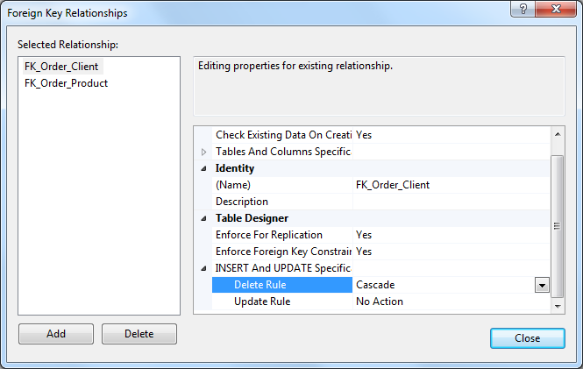

Now you should be able to delete a row from Client table. What happens as a whole? Document your findings.

Build one Word document where you copy and paste all the source code (from the final solution) you have generated during solving the task. Your word document should also show the functional details of the solution. One generic example from functional details: if the task is to make some calculations with the user input, use print screens to show one successful use case where the input is received and calculations will be completed. Your document need not be a complete road map from each individual step, but it should still be understandable and show street credibility to the outside reader. Use exactly the same format you would use with the thesis document (not description sheet, please!), or alternatively use the shorter report template. You can find the instructions from the student intranet.

**Theory part** can be at the beginning of or at the end of your word document where you have your **Practical part**. Remember to add all the references used in your document!

Take your script files together with your Word file and zip it into one file. Return that composite zip file to Moodle.

Assessment: Half from the points come from **Theory part**, another half from **Practical part**.

Submit your task before deadline! It is not possible to return this task

after the deadline.